The Kaffa Region in Ethiopia (formerly Abyssinia ) is the birthplace of coffee
There are several species of coffea; the two most well known species are caffea arabica (arabica) and caffea canephora (robusta). Here are a few quick facts:
Caffea Arabica
- Trees usually produce cherries for as long as 60 years (in some cases up to 100!)
- Require substantial amounts of water
- Cultivated at 1300 to 1500 m altitude (susceptible to cold/freezing temperatures)
- Nine months to ripen (Takes roughly 7 years to completely mature)
- More desirable taste characteristices (about 1/2 the caffeine content as robusta)

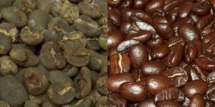
Unroasted and Roasted Caffea Arabica Beans
Arabica Producing Countries: Indonesia ( NTT, Sumatra , Flores ) , Ethiopia, Yemen, Tanzania, Papua New Guinea, Mexico, Cuba, Jamaica, Haiti, Dominican Republic, Puerto Rico, Venezuela, Martinique, El Salvador, Guatemala, Hawaii, Honduras, Nicaragua, Costa Rica, Panama, Ecuador, Columbia, Peru, Bolivia, Guyana, Paraguay.
Caffea Canephora (robusta)
- Trees usually mature within three years
- Can withstand and tolerate environmental conditions better than arabica
- Used in espresso blends to achieve both crema (see pic) and the desired heightened pungency on the palate
- Vast amount of caffeine content, less desired taste (much cheaper than arabica), generally used to make instant coffee
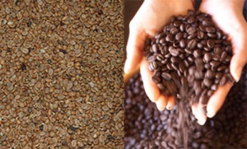
Unroasted and Roasted Canephora (Robusta) Beans
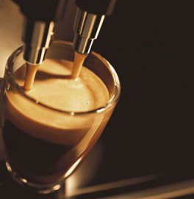
Crema
Robusta Producing Countries: Rwanda, Madagascar, Ivory coast, Uganda, Indonesia (Flores ,Java, Bali and Sulawesi) , Borneo, Burundi, Democratic Republic of Congo, Sri Lanka, Angola, Vietnam, Timor.
Countries that Produce Both Arabica and Robusta: Indonesia , Brazil and India

The Arabica bean (Coffea arabica), named by the Arabs, is always the more expensive of the two. These trees are grown in semi-tropical climates near the equator, both in the western and eastern hemispheres, at high altitudes. Because ripe Arabica cherries (green beans) fall to the ground and spoil, they must be carefully monitored and picked at intervals, which increases production costs. Also the Arabica beans are more prone to disease, Whilst the high concentration of caffeine in Robusta beans helps protect them from pests.
Robusta (Coffea canephora), which is grown exclusively in the eastern hemisphere, also thrives in equatorial climates, but at low altitudes. Their cherries require less care since they remain on the tree after they ripen. Robusta beans have twice the caffeine of Arabica, but less flavor.
The perfect blend is always a blend of coffee beans from different origins , It could be 100% Arabica beans or a mix of robusta and Arabica together. Usually the better coffee blends are always a mix of the 2 families, where the Arabica gives the flavour and the character and the robusta adds the crema and kick of the caffeine.
Which ever blend you use the main problem is what kind of Arabica or Robusta beans are they?
There are more than 100 different varieties of Arabica and Robusta coffee beans in relation to the country of origin. The quality of the coffee bean can vary widely within a single region and depends upon a number of factors. The producer, their harvest methods and the year of growth can significantly affect the taste, aroma and quality of the beans.
We should not be carried away by the high price or by the 100% Arabica labels. Ask where the beans are grown. As a general rule, the best Arabica Beans come from South America, whilst the best Robusta beans come from India.
It also preferable to buy the coffee beans already packed in a special aluminum foil bag. Also make sure that the same bag has the special one-way valve on its extremity. Indispensable for keeping the coffee at is optimum state.
Stay away from the beans stored in the supermarket dispenser. Although they look traditional and glamorous, they often store old beans and can be a breeding ground for insects.

